**Wehelp!**

Types of roles/user

1.mechanic

2.Admin

3.Costumer

Functionalities/process

1.Mechanic

# Registration page/Signup

# login page

# profile

# vehicle repair

# water wash

2.Admin

# profile

# verify the user

# Validate users

# send payment to mechanic

# Assign mechanic to user

3.Costumer

# Registration/Signup

# login

# profile

# view near service

# set appointment

# book and cancel service

input and action

1.Mechanic

input

# sign up

1.name

2.email

3.ph_no

4.password

5.confirm password

action

1.phNum_Authentication

2.login with google

3.show and hide password

4.submit

5.Agree terms and condition

# login

input

1.login

2.password

action

1.forgot password

2.remember me

3.proceed

4.hide password

# profile

input

1.name

2.ph_no

3.address

4.photo

5.aadhar card

6.email

# bussiness_profile

1.shop_name

2.shop_address

3.number of worker

4.model of bike repair

5.mode of car repair

6.waterwash

# bank_details

1.acc_no

2.acc_bankName

3.IFSC_code

4.bank_branch

5.UPI_id

action

1.edit and save

2.validate_bank value

3.phone_call verification-via check aadhar and address details

4.monthly analysis got paid

2.User

# sign up

1.name

2.email

3.ph_no

4.password

5.confirm password

action

1.phNum_Authentication

2.login with google

3.show and hide password

4.submit

5.Agree terms and condition

# login

input

1.login

2.password

action

1.forgot password

2.remember me

3.proceed

4.hide password

# profile

input

1.name

2.ph_no

3.address

5.email

action

1.validate_email

2.ph_no_authentication

# service to user

input

1.car/bike model

2.issue description

3.address for service

4.water wash from timing to timings

action

1.geolocation

2.track

3.submit issues

4.call mechanic

5.search

3.Admin

# profile

input

1.name

2.phone_no

3.mail_id

4.password

5.address

6.photo

7.adminstation role

8.payment role

action

1.generate_userId

2.submit

3.mail validation

4.ph_no authentication

# login

input

1.user_id

2.password

action

1.hide password

2.remember password

3.ph_no authentication

4.forgot password

# payment

Input

1.enter user_id or phone number

Action

1.get data from user table

2.pay to user

Wireframe

Database

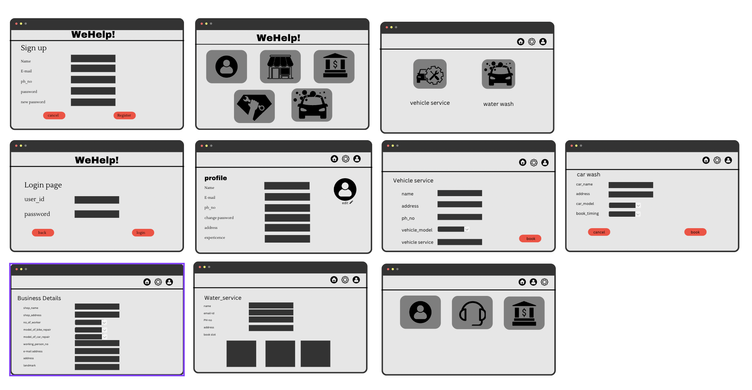

Mechanic database

|  |  |  |  |  |  |
| --- | --- | --- | --- | --- | --- |
| mech_id(P.K) | Name | ph_No | email_id | Address | Password |
|  |  |  |  |  |  |
|  |  |  |  |  |  |

|  |  |  |  |
| --- | --- | --- | --- |
| mech_Id(F.K) | Acc_No(P.K) | Branch | IFSC_code |
|  |  |  |  |
|  |  |  |  |

|  |  |  |  |
| --- | --- | --- | --- |
| mech_Id(F.K) | Shop_Name(P.k) | Shop_address | no_of_worker |
|  |  |  |  |
|  |  |  |  |

|  |  |  |  |  |  |
| --- | --- | --- | --- | --- | --- |
| user_id(P.K) | Name | ph_No | email_id | Address | Password |
|  |  |  |  |  |  |
|  |  |  |  |  |  |

|  |  |  |
| --- | --- | --- |
| user_Id(P.K) | Car/bike_model(F.K) | Description |
|  |  |  |
|  |  |  |